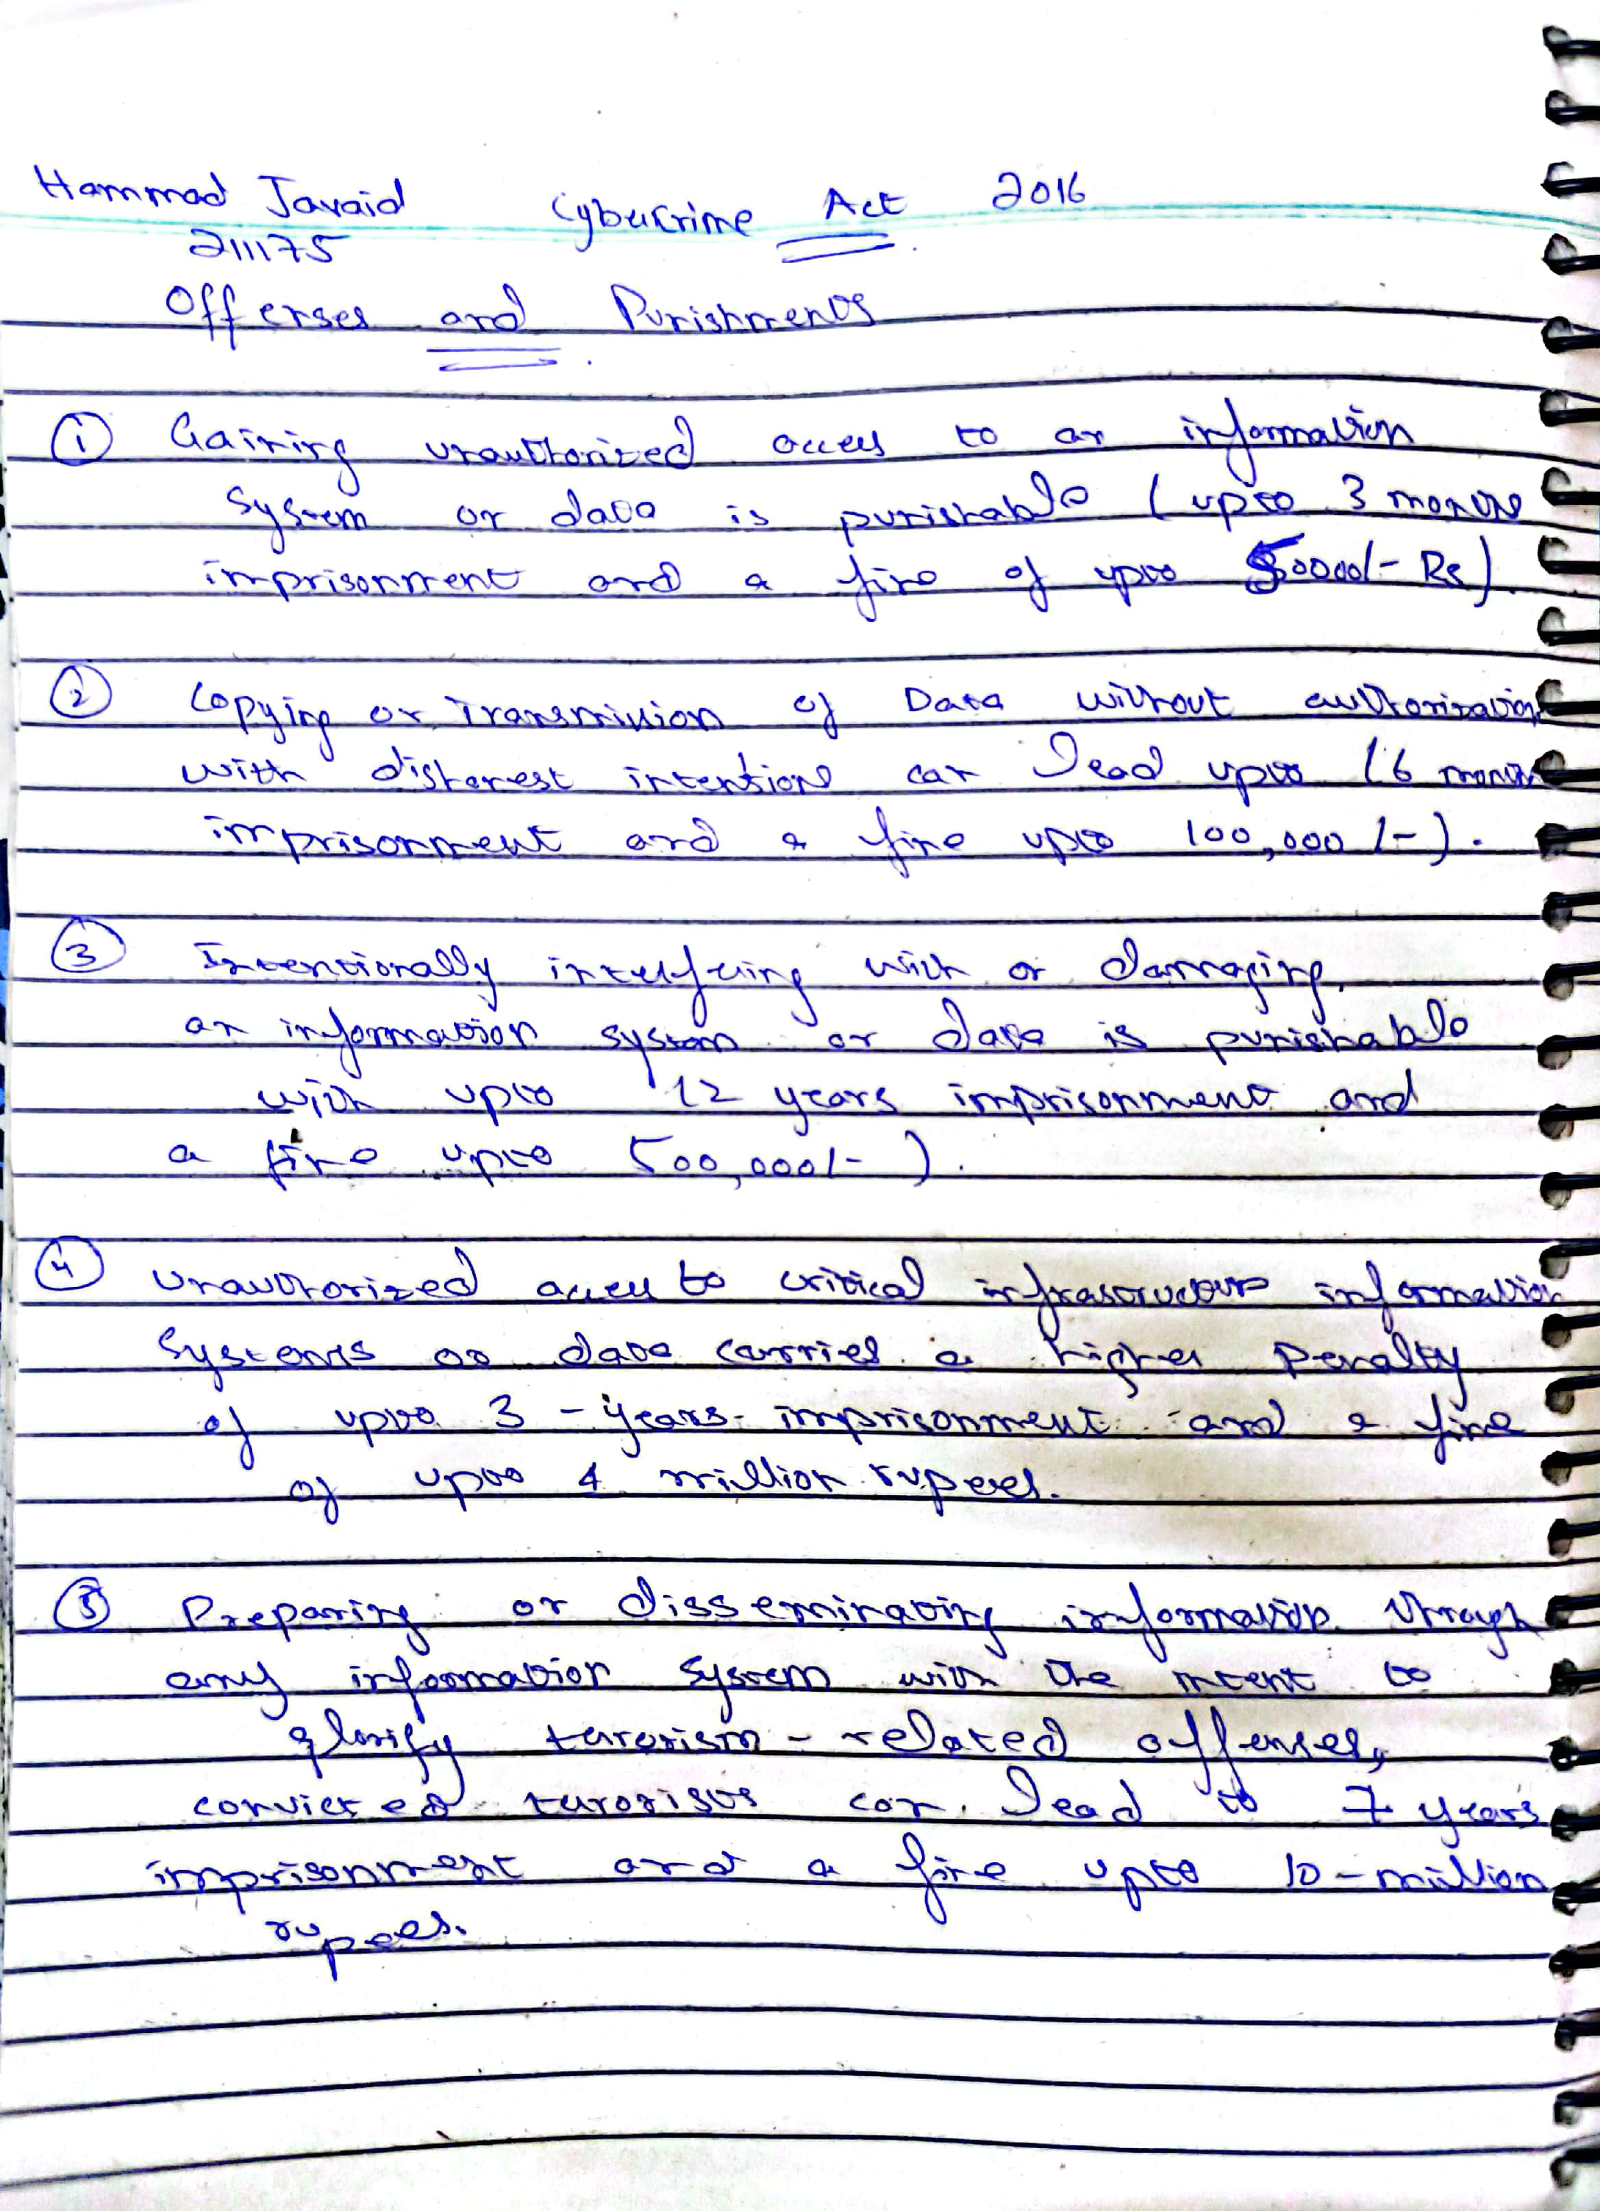

[Scanned with CamScanner](https://v3.camscanner.com/user/download)

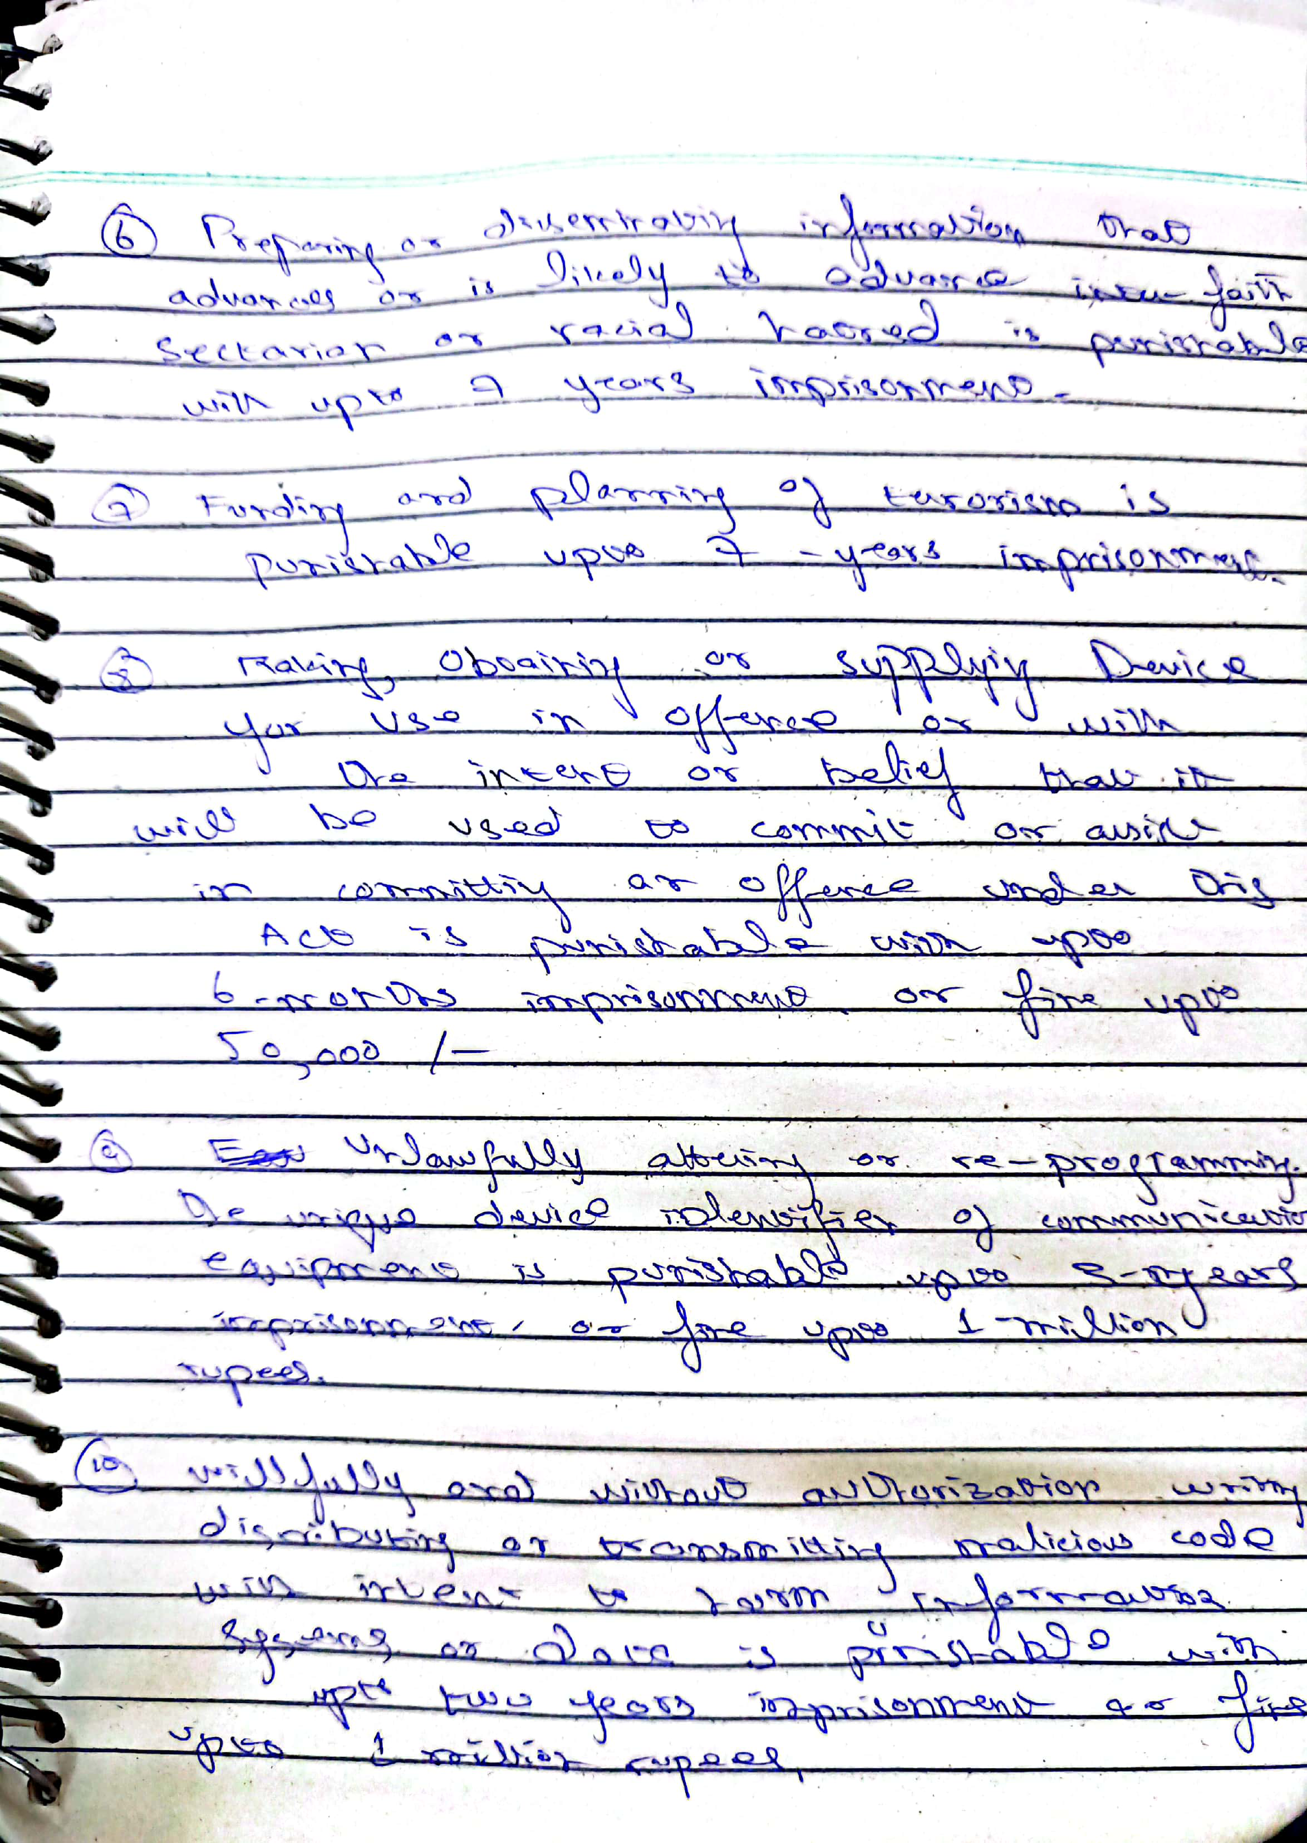

[Scanned with CamScanner](https://v3.camscanner.com/user/download)